/**/LINEAR SEARCH//**

**#include<stdio.h>**

**#define MAX_SIZE 100**

**int main()**

**{**

**int arr[MAX_SIZE];**

**int n,i,search;**

**printf("Enter the number of elements:");**

**scanf("%d", &n);**

**printf("Enter the elements of an array:");**

**for(i=0;i<n;i++)**

**{**

**scanf("%d",&arr[i]);**

**}**

**printf("Enter the element to search:");**

**scanf("%d", &search);**

**for(i=0;i<n;i++)**

**{**

**if(search == arr[i])**

**{**

**printf("The %d element is present at the position:%d\n", search,i+1);**

**break;**

**}**

**}**

**if(search != arr[i])**

**{**

**printf("The element is not present in the array", search);**

**}**

**return 0;**

**}**

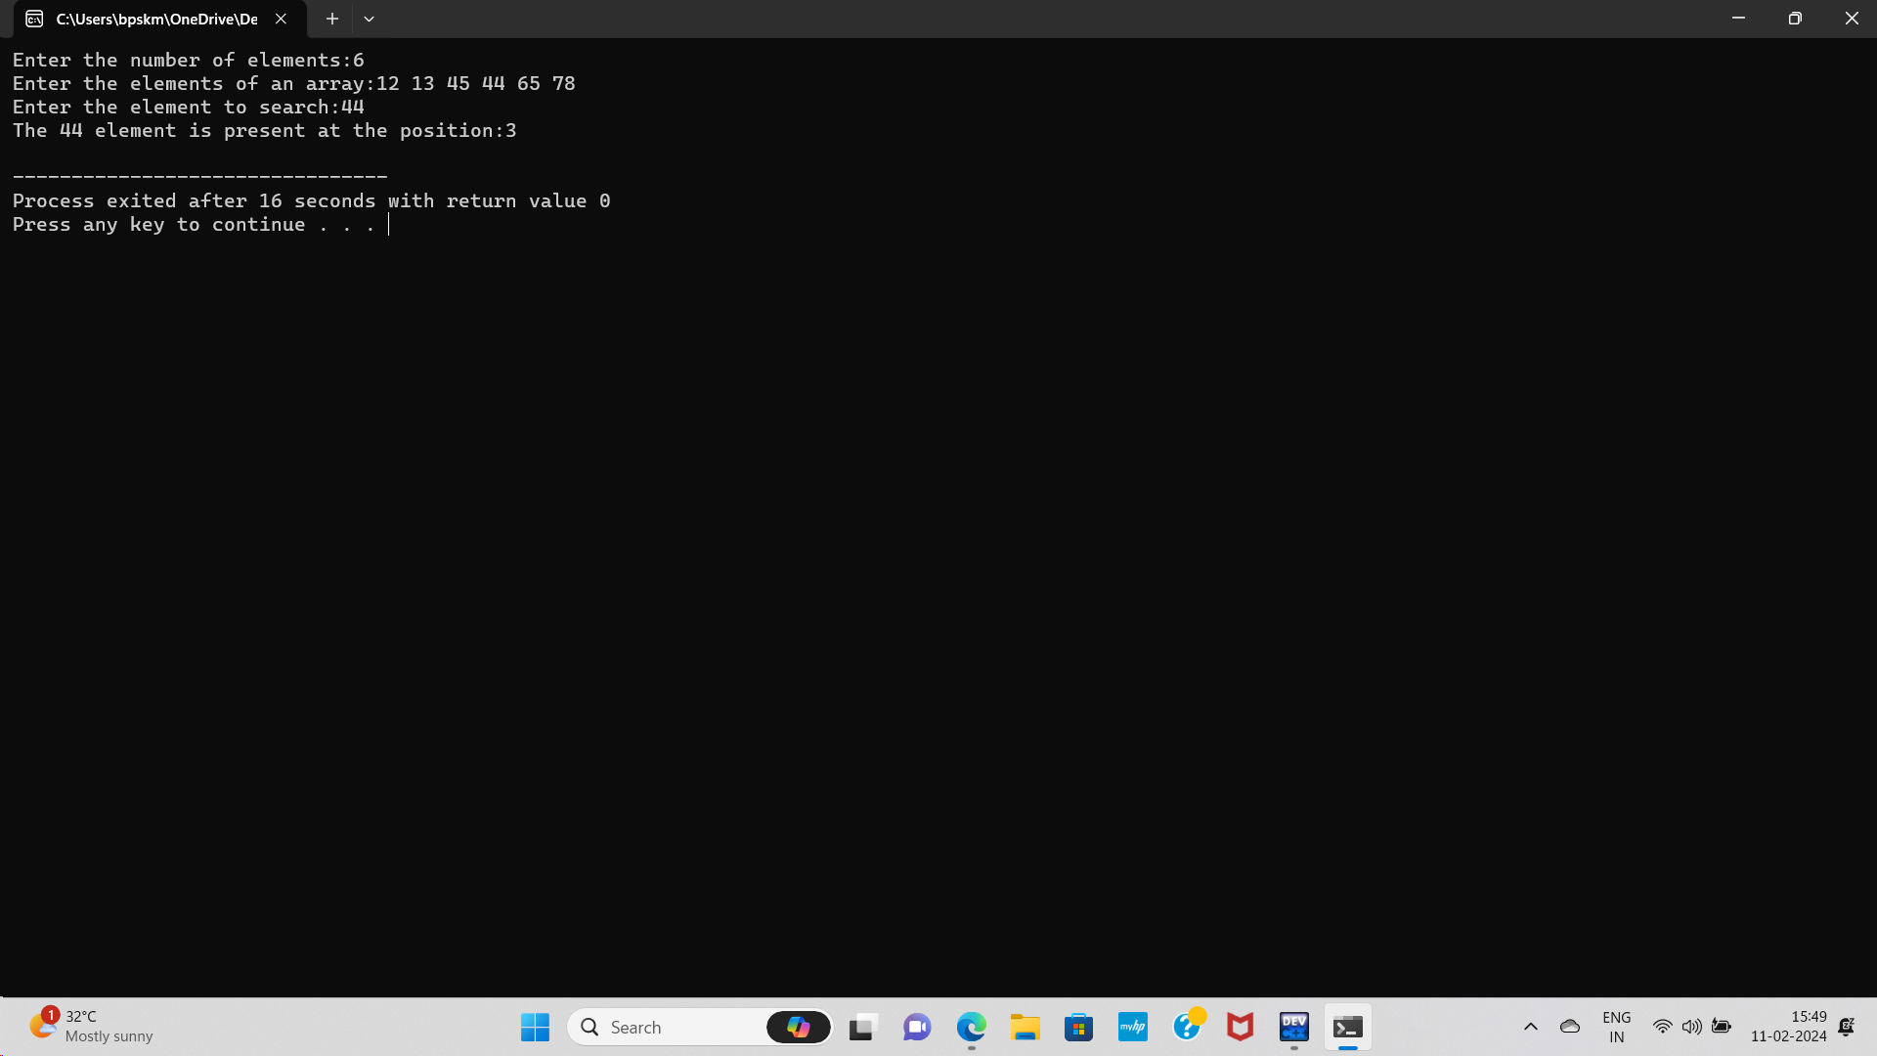

**//BINARY SEARCH//**

**#include <stdio.h>**

**int binarySearch(int arr[], int size, int target)**

**{**

**int low = 0, high = size - 1;**

**while (low <= high)**

**{**

**int mid = low + (high - low) / 2;**

**if (arr[mid] == target)**

**return mid;**

**else if (arr[mid] < target)**

**low = mid + 1;**

**else**

**high = mid - 1;**

**}**

**return -1; // target not found**

**}**

**int main()**

**{**

**int arr[10],target;**

**printf("Enter the array elements:");**

**for(int i=0;i<10;i++)**

**{**

**scanf("%d",&arr[i]);**

**}**

**printf("Enter the target you want to search:");**

**scanf("%d",&target);**

**int size = sizeof(arr) / sizeof(arr[0]);**

**int index = binarySearch(arr, size, target);**

**if (index != -1)**

**printf("Element %d found at index %d.\n", target, index);**

**else**

**printf("Element %d not found in the array.\n", target);**

**return 0;**

**}**

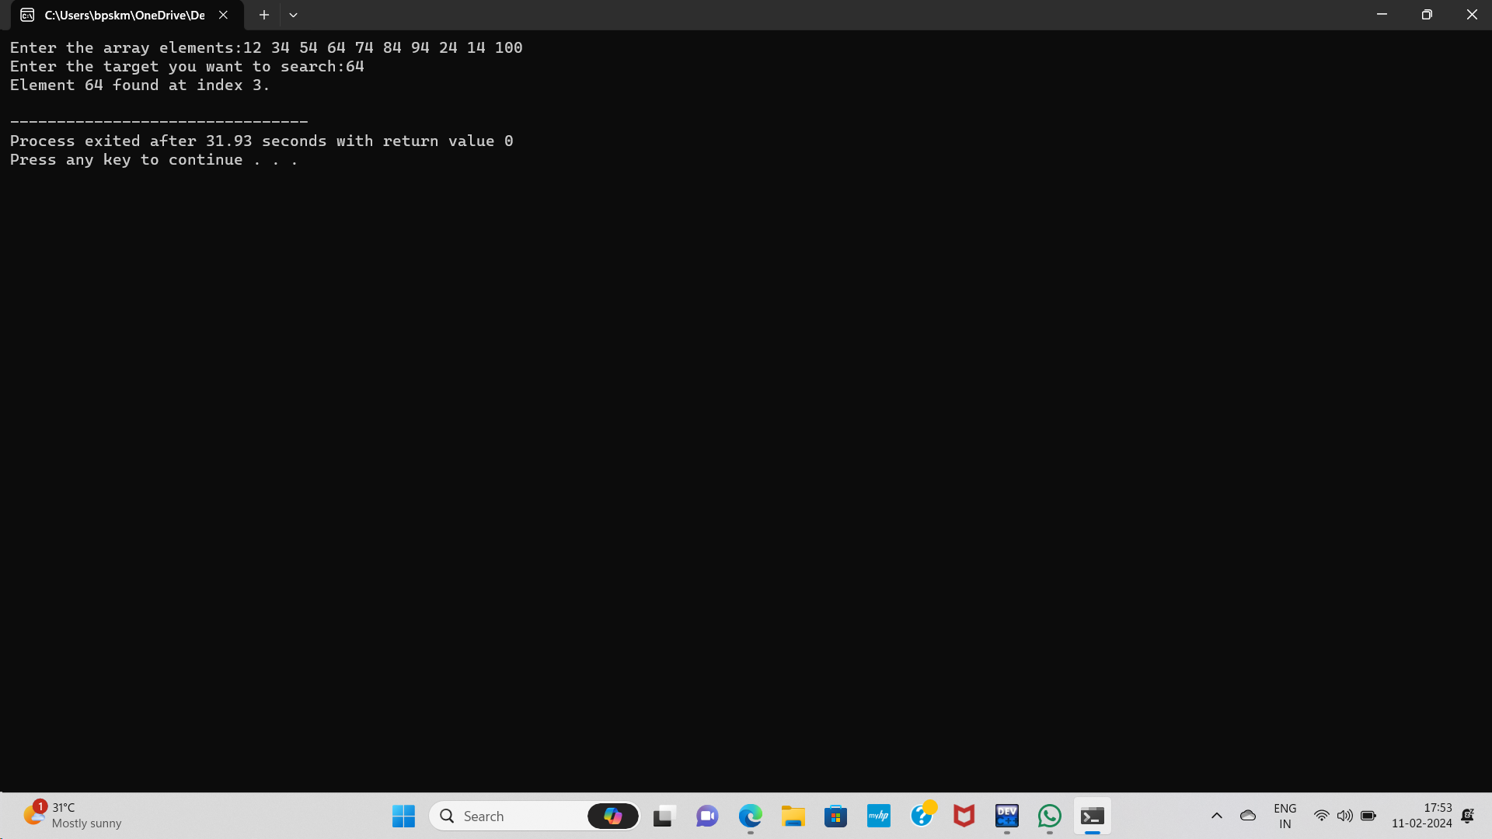

**Or**

**//BINARY SEARCH//**

**#include <stdio.h>**

**int binarySearch(int arr[], int size, int target)**

**{**

**int low = 0, high = size - 1;**

**while (low <= high) {**

**int mid = low + (high - low) / 2;**

**if (arr[mid] == target)**

**return mid;**

**else if (arr[mid] < target)**

**low = mid + 1;**

**else**

**high = mid - 1;**

**}**

**return -1; // target not found**

**}**

**int main()**

**{**

**int arr[] = {2, 4, 6, 8, 10, 12, 14, 16, 18, 20};**

**int size = sizeof(arr) / sizeof(arr[0]);**

**int target = 16;**

**int index = binarySearch(arr, size, target);**

**if (index != -1)**

**printf("Element %d found at index %d.\n", target, index);**

**else**

**printf("Element %d not found in the array.\n", target);**

**return 0;**

**}**

